**Smart greenhouse supports growing lettuce**

**Team Leader:** Nguyen Tuan Thanh

**Group Members:**  Luu Minh Huong, Tran Quy Dat, Tran Dinh Tuan,

Tran Danh Thuong, Vu Duy Hanh

**Adviser:** Mr. Khuat Duc Anh

# 

# 

# 

# 

# 

# 

**TABLE OF CONTENTS**

# Introduction 5

1.1 Rationale of the Study 5

1.2 The purpose of project 7

1. Proposed features of project 8

2.1 Monitoring air temperature and humidity 8

2.2 Automatic irrigation 8

2.3 Cooling 9

2.4 Stimulating growth using LED lights 10

1. Architecture diagram 10

3.1 Examples of real-life smart 10

3.1.1 IoT based smart greenhouse research by Indian authors 10

3.1.2 Research Internet of Things Based Smart Greenhouse: Remote Monitoring and Automatic Control of a group of students from Monash University, Australia. 11

3.2 System Architecture Diagram 13

3.3 Device structure diagram 14

1. Materials 15

4.1 Specifications 15

4.2 The necessary components for the project 15

4.2.1 Air temperature sensor 15

4.2.2 Air humidity sensor 17

4.2.3 Soil moisture sensor 18

4.2.4 Cloud 19

4.2.5 Microcontroller 22

4.2.6 Other devices 24

1. Implement 26

5.1 Circuit 26

5.2 Algorithm flowchart 27

1. Results and Discussion 28

6.1 Blynk web interface 28

6.2 Blynk app interface 30

1. Conclusion and development direction 31
2. References 31

**List of Figures**

Fig 1. Block diagram of the system of IoT based smart greenhouse research 10

Fig 2. Implementation setup of IoT based smart greenhouse research 11

Fig 3. Block diagram of the system of Research Internet of Things Based Smart Greenhouse: Remote Monitoring and Automatic Control 12

Fig 4. Implementation setup of Research Internet of Things Based Smart Greenhouse: Remote Monitoring and Automatic Control 13

Fig 5. System Architecture Diagram of project 13

Fig 6. Device structure diagram of project 14

Fig 7.Circuit of project 26

Fig 8. Algorithm flowchart of project 27

Fig 9. Web control screen 28

Fig 10.Soil moisture chart 28

Fig 11.Air temperature chart 29

Fig 12.Air humidity chart 29

Fig 13.Mobile control screen 30

**List of Tables**

Table 1. General specifications 15

Table 2. Comparison 3 temperature sensor devices 16

Table 3. Comparison 4 air humidity sensor devices 17

Table 4. Comparison 3 soil moisture sensor devices 18

Table 5. Comparison 2 clouds 19

Table 6. Comparison 4 microcontrollers 22

Table 7. Other devices 24

# **Abstract:** *A greenhouse is a controlled environment where plants are cultivated. Nowadays, urbanization and land scarcity have led to a high demand for building greenhouses primarily for farming purposes. With the advancement of technology, we can now monitor and control multiple greenhouses using IoT from a centralized wireless location.[1] Therefore, our project aims to develop a Smart Greenhouse to support lettuce cultivation, combining advanced technologies to optimize the growth and development process of lettuce plants. The smart greenhouse utilizes Internet of Things (IoT) devices, sensors, and automation systems to monitor environmental factors such as temperature, humidity, light, and control irrigation and misting. The smart greenhouse provides real-time data on environmental conditions, helping growers make informed decisions to adjust parameters for maximizing plant health and productivity. Our project strives to bring numerous benefits, including improving the quality and yield of crops without requiring excessive manual intervention.*

# **Key words**: temperature, humidity, lighting quality, Soil moisture sensor, Blynk Cloud

# **1. Introduction**

## 1.1 Rationale of the Study

Lettuce is a popular leafy vegetable that offers numerous health benefits and is rich in nutrients. It is a good source of dietary fiber, which helps enhance digestive function and maintain a healthy digestive system. It also contains essential vitamins and minerals such as vitamin C, vitamin K, vitamin A, potassium, and folic acid, providing necessary nutrients for the body.

The high antioxidant content in lettuce, such as beta-carotene and other antioxidants, helps protect cells from damage caused by free radicals and may reduce the risk of chronic diseases such as cancer and heart disease. Lettuce also aids in weight management and helps maintain water balance in the body due to its low-calorie content and natural water content. [2]

Furthermore, lettuce has the ability to reduce feelings of stress and improve mood. Many believe that consuming lettuce can help reduce stress and anxiety while providing a refreshing and mentally invigorating sensation.[3]

With all these benefits, it is no surprise that lettuce has become an essential part of a healthy and balanced diet. Adding lettuce to daily meals not only provides necessary nutrition but also brings numerous health benefits and enhances overall well-being.

The growth and development process of lettuce includes several stages from seed to becoming a mature plant that produces flowers and fruits. Here is a summary of these stages:

1. Seed: Lettuce seeds are small and have a pointed shape, measuring about 1/8 inch. Depending on the variety, the seeds can have different colors such as white, black, brown, or gray. Providing sufficient light, water, and care is essential for the seeds to germinate and develop into seedlings.
2. Germination stage: This is when the seedlings "wake up" and begin to grow. Under suitable conditions, lettuce seeds will germinate within 5 to 10 days, although the process may be slower at lower temperatures. As the germination process continues, two small leaves known as cotyledons appear.
3. Seedling stage: As the lettuce seedling continues to grow, it will produce its first true leaves. If you provide the seedlings with proper light, temperature, and humidity, they will continue to develop. More leaves will emerge, and the existing leaves will become larger.
4. Rosette Stage: This is the stage where the leaves of the lettuce plant develop into distinct round shapes. The appearance of this stage may vary depending on the type of lettuce you are growing, but regardless of the lettuce variety, this stage typically lasts from 25 to 50 days.
5. Cupping stage: In this stage, lettuce leaves start to grow larger and curl inward, forming a cup-like shape. This stage typically lasts about a week.
6. Heading stage: During this stage, the lettuce leaves continue to develop and form a dense cluster at the top of the plant. The outer lettuce leaves start to curl and cover the smaller leaves in the center. Depending on the variety and the time of the year, the flowering stage may last from 20 to 45 days. This is the ideal time to harvest lettuce for use as food.
7. Bolting stage: This is the final stage of lettuce when the plant starts to produce flower stalks and fruits. Usually, at this stage, lettuce has passed the appropriate time for harvesting and may develop a bitter taste or poor quality.

The growth process of lettuce can vary depending on the lettuce variety and environmental conditions such as temperature, light, humidity, and soil nutrition.[4]

However, traditional lettuce farming can face many challenges such as climate change, resource scarcity, and urbanization.[5] Research on smart greenhouse farming for lettuce focuses on monitoring and caring for lettuce plants during their development from seedlings to maturity to enhance productivity and efficiency in modern agricultural production. Additionally, the use of greenhouses helps control the quality and safety of food. Managing the farming environment and monitoring the growth process can ensure that lettuce is produced in a clean environment, free from pollution, and adheres to food safety regulations.

## 1.2 The purpose of project

The "Smart Greenhouse for Lettuce Farming" model serves the purpose of monitoring and control. This system has the capability to monitor and control important factors such as temperature, air humidity, soil moisture, and greenhouse equipment. The monitoring system is designed to track and record essential environmental parameters for plant growth. Temperature and air humidity are measured and the data is sent to a control center. Soil moisture is also monitored to ensure that plants receive the necessary amount of water. The system can also control greenhouse equipment such as automatic irrigation pumps and misting systems. This control can be executed through two modes: automatic mode and remote control via a web application and mobile phone. Another significant feature of the system is the ability to stimulate plant growth through artificial lighting. This ensures that plants receive adequate light for optimal development. Lastly, the system is equipped with ventilation and cooling capabilities using fans, maintaining an ideal environment for plant growth and preventing overheating inside the greenhouse. Overall, this research introduces an efficient smart greenhouse system for lettuce farming. The system provides monitoring and control of crucial factors while offering flexible operation modes: automatic and remote control via web and mobile app.

# **2. Proposed features of project**

## 2.1 Monitoring air temperature and humidity.

The air temperature and humidity levels in the greenhouse are accurately and continuously collected from temperature sensors and air humidity sensors. The data for these parameters is then pushed to the Cloud. Users can monitor the changes in air temperature and humidity over time through the app or web interface to assess and analyze the impact of these environmental factors on the growth process of lettuce plants.

## 2.2 Automatic irrigation

Through the soil moisture sensor, data is analyzed to determine the soil moisture level. If the moisture level falls below the predefined threshold, the smart greenhouse system activates the automatic irrigation system to water the lettuce plants. This ensures that the plants receive adequate moisture for their growth and development. Additionally, users can monitor the soil moisture data on the provided web and app interface, and manually control the operation of the irrigation system by turning the pump on or off. This gives users flexibility and control over the irrigation process, allowing them to make adjustments as needed.

## 2.3 Cooling

Through temperature and humidity sensors, data is analyzed to determine if the temperature exceeds the set threshold in the smart greenhouse system. If the temperature is too high, the system automatically activates the fans and misting system until the temperature returns to the initial permissible level. Additionally, users have the ability to remotely control either the fan or the misting system, or activate both devices simultaneously, using the app or web interface.

## 2.4 Stimulating growth using LED lights

Users, by observing the light quality such as low light intensity in the greenhouse environment, can utilize the remote LED control feature through the app or web to enhance the stability of the lettuce's photosynthesis process. Additionally, the LED lights can also automatically turn on based on the preset schedule set by the user through the mobile application.

# **3. Architecture diagram**

## 3.1.Examples of real-life smart greenhouse projects

### 3.1.1 IoT based smart greenhouse research by Indian authors

### 

Figure *1. Block diagram of the system [3]*

* The study utilizes light sensors to control the LED lights, turning them on whenever the light intensity is low for photosynthesis, ensuring faster photosynthetic rates than plant growth.
* Air humidity and temperature inside the greenhouse are measured using sensors, and whenever the temperature is high or the air humidity becomes too low, the misting system will activate to provide the necessary humidity and cool the temperature.
* The soil moisture sensor is inserted deep into the soil-filled box. When the soil moisture is below the required threshold, the irrigation system will operate to supply water to the soil.

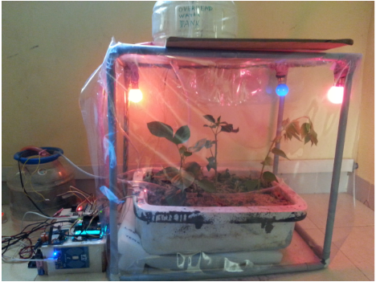

Figure *2. Implementation setup*

### 3.1.2 Research Internet of Things Based Smart Greenhouse: Remote Monitoring and Automatic Control of a group of students from Monash University, Australia.

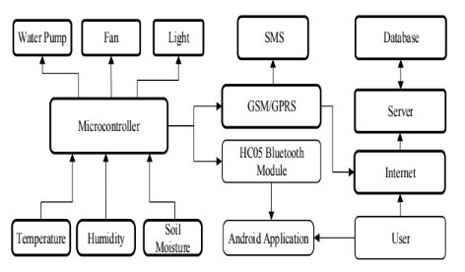

Figure *3. Block diagram of the system [4]*

* The study incorporates several sensors: soil moisture sensor, temperature and humidity sensor, and a light sensor used to detect day/night conditions.
* Initially, the microcontroller initializes the GSM/GPRS module and HC05 Bluetooth module to connect the system to the network. The microcontroller then measures the soil moisture level and irrigates the plants if it falls below the threshold. Next, it retrieves the values of both temperature and humidity, controls the airflow in and out, and starts/stops the misting system accordingly. It then determines the day or night condition using the LDR sensor. Finally, all the data is sent to the user by sending SMS messages via GSM, to the mobile application using HC05, and to the server via GPRS. There is also an LCD display along with an Android application to visualize real-time data.[5]

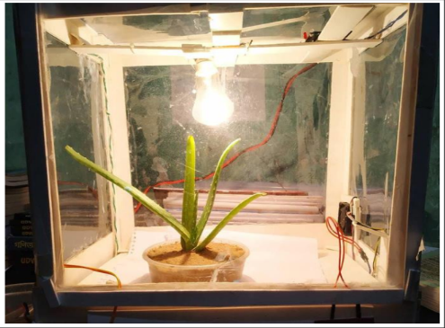

Figure *4. Implementation setup*

## 3.2 System Architecture Diagram

After consulting the studies on the same topic, our team decided to come up with a system architecture diagram for the lettuce growing greenhouse as follows:

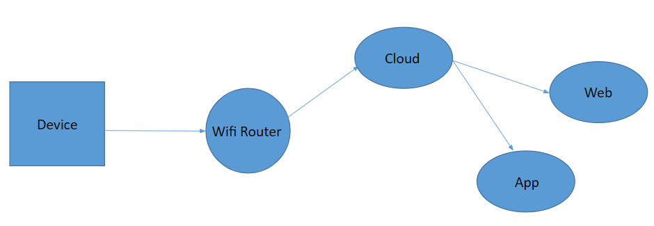

Figure 5. System Architecture Diagram of project

The system comprises 5 components: The device transmits data to the Cloud via a Wi-Fi router, and then the data is sent back to the App and Web for display on the screen, allowing users to view the parameters and control them remotely if desired.

## 3.3 Device structure diagram

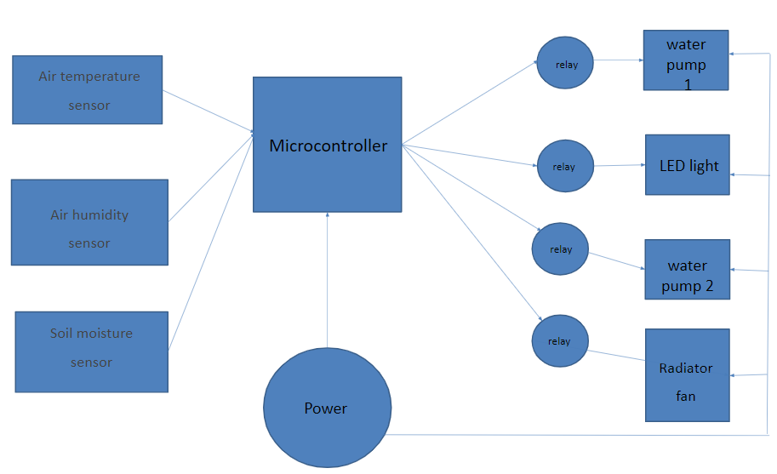

Figure 6. Device structure diagram of project

Our model consists of sensors: temperature sensor, air humidity sensor, and soil moisture sensor. These sensors are controlled by a microcontroller with an Internet connection to transmit data. The output devices include: 2 pumps (for supplying water to the misting system and irrigation), LED lights, and a ventilation fan. All components are powered by a power supply with appropriate voltage for each component.

# **4. Materials**

## 4.1 Specifications

| **Parameter** | **Property** | **Unit** |
| --- | --- | --- |
| Operating voltage | 5,12 | V |
| Network | Wifi,4G |  |
| Connect ability | wifi |  |
| Processor | Esp8266 | 1 bộ |
| Range | 0.5 | m^2 |
| Sensor | DHT11  M9BI |  |

Table 1. General specifications

## 4.2 The necessary components for the project:

### 4.2.1 Air temperature sensor

| **Name** | DHT22 | *DHT11* | RTD |
| --- | --- | --- | --- |
| **Input voltage** | 3.3-5.0V | 3.3 - 5.0 V | 3.3-5.0V |
| **Communication standards** | 1 wire | TTL, 1 wire | 4-20mA, Modbus, I2C |
| **Measuring range** | -40 - 80°C | 0-50°C | -200°C - 600°C. |
| **Error** | ±0.5°C | ±2°C | ±0.1°C or ±0.25°C |
| **Number of pins to plug** | 3 | 3 | 3 |
| **Price** | 2-5 USD | 1-3 USD | 10 USD đến 50 USD |
| **Response speed** | 1-2s | 2s | It can be a few seconds or a few tens of seconds |
| **Image** |  |  |  |

Table 2. Comparison 3 temperature sensor devices

Our team has extensively researched various sensor types available on the current market and has provided technical specifications for three types in the table above. Among the many temperature sensors available, we have decided to use the DHT11 sensor for several reasons. Firstly, in terms of measurement range and accuracy, for a greenhouse used for growing lettuce, the temperature range of concern is from 15°C to 30°C, and the test climate in the region always falls within the range of 0°C to 50°C, which aligns well with the measurement range of the DHT11 sensor, and its small margin of error does not significantly affect the growth and development of the plants. Secondly, we have chosen to use the DHT11 sensor for its convenience as it integrates both temperature and humidity measurements, reducing the number of sensors needed and keeping the cost low. Lastly, we have already been provided with the DHT11 sensors, allowing us to make use of them without incurring any additional costs.

### 4.2.2 Air humidity sensor

| **Name** | AM2301 | SHT15 | HTU21D | *DHT11* |
| --- | --- | --- | --- | --- |
| **Input voltage** | 3.3-5.0 VDC | 2.4-5.5 VDC | 1.5-3.6 VDC | 3.3 - 5.0 V |
| **Communication standards** | 1 wire | I2C or SMBus | I2C | TTL, 1 wire |
| **Measuring range** | 0 - 100%RH | 0 - 100%RH | 0 - 100%RH | 20 - 90% |
| **Error** | ± 3% RH | ± 2% RH | ± 2% RH | ± 5% RH |
| **Number of pins to plug** | 3 pins: VCC, GND và DATA | 4 pins: VDD, GND, SDA và SCL | 4 pins: VDD, GND, SDA và SCL | 3 pins: VCC, GND và DATA |
| **Price** | 50~150k VND | 200~300k VND | 50~150k VND | 1-3 USD |
| **Response speed** | 1-2s | < 15s | about a few milliseconds | 2s |
| **Image** |  |  |  |  |

Table 3. Comparison 4 air humidity sensor devices

Our team has researched several types of air humidity sensors available on the market today and provided some technical specifications for popular types in the table above. We have decided to use the DHT11 sensor to measure air humidity for several reasons. Firstly, as mentioned in the previous section about temperature sensors, the DHT11 sensor not only measures environmental temperature but also integrates the function of measuring air humidity. This reduces the number of sensors used, saving costs for the smart greenhouse system. Secondly, the measurement range of the DHT11 sensor is also suitable for the criteria of our model as well as the testing area. Although it has a larger margin of error compared to other types, it does not significantly affect the growth of plants or the monitoring process. Lastly, we already have the DHT11 sensors available, and they meet the requirements, so the team has decided to use them.

### 4.2.3 Soil moisture sensor

|  | **M9BI** | **JR6A** | **4W49** |
| --- | --- | --- | --- |
| **Input voltage** | 3.3-5V | 4.5~5.5VDC | 3.3~12VDC |
| **Output** | AOUT, DOUT, VCC, GND | AOUT, VCC, GND | AOUT, DOUT, VCC, GND |
| **AOUT** | according to the corresponding power supply voltage | 0 ~ 3.0 VDC | according to the corresponding power supply voltage |
| **DOUT** | High or Low | None | High or Low |
| **Outstanding Features** | High sensitivity, adjustable by rheostat | Capacitive soil moisture sensor is hard to corrode | Built-in anti-corrosion probe for durability and stability |
| **PCB size** | 3cm x 1.6cm | 98 x 23mm | 3.6 x 1.5cm |
| **Image** |  |  |  |
| **Price** | 12.000 VND | 20.000 VND | 98.000 VND |

Table 4. Comparison 3 soil moisture sensor devices

Through research, our team has gathered the technical specifications as well as the prices of several types of soil moisture sensors available on the market, which are recorded in the table above. Based on this information, we have decided to use the M9BI soil moisture sensor instead of the other types for several reasons. Firstly, the M9BI sensor has high sensitivity and can be adjusted using a variable resistor. The returned results can be converted into specific percentages, making it easy to monitor and control. The final reason for our decision is the cost. With a price range of 12,000VND to 18,000VND, the results it provides are sufficient for our needs in this model.

### 4.2.4 Cloud

|  | **ThingSpeak** | ***Blynk IOT*** |
| --- | --- | --- |
| **Main functions** | - The devices can be easily configured and send data to Thingspeak using communication protocols including MQTT and HTTP.  -Data storage and analysis are performed in the cloud.  Real-time data visualization is possible.  -It can be used with Matlab for data analysis.  -It does not require a server and web software to build an IoT system prototype.  -Integration with other web services such as Twitter and IFTTT is possible. | -It provides user-friendly utilities.  -Data connection history can be monitored using various connectivity options such as Wi-Fi, Bluetooth, Ethernet, GSM, etc.  -Cloud data storage is available.  -Easy integration and addition of new features can be done using integrated virtual pins on the Blynk app.  -It provides API and a similar user interface for all supported devices and hardware. |
| **Compatibility with devices** | * Arduino * Raspberry pi * Matlab * Module ESP8266 * Module ESP32 * LoRaWAN | * Arduino * Raspberry pi * Module ESP8266 * Module ESP32 |
| **Advantages** | * Easy to use * Open-source * Cloud data storage * Integration with other web services * Data visualization | * Easy to use * Cross-platform compatibility * Support for multiple types of connections * Versatile functionality * Large community support |
| **Disadvantages** | Limited customization: Users may be limited by the predetermined functionality of the platform. This can restrict the ability to customize ThingSpeak according to their specific needs. | Device limit: The free version of Blynk has a limitation on the number of devices that users can connect and control. |
| **Version (free)** | - 8200 messages per day  - Data update every 15 seconds  - 4 channels  - Matlab computation time: 20 seconds  - Image feature not available | - 2 devices, 5 users  - 3 device templates  - Free widgets  - 10 data streams/widgets per template  - Data storage for 1 week |

Table 5. Comparison 2 clouds

On the current market, based on our research, there are several good cloud platforms such as Amazon Web Services (AWS) IoT, Blynk IoT, ThingSpeak, etc. Each tool has its own advantages and disadvantages. However, after considering the comparison between Blynk IoT and ThingSpeak as presented in the table, our team has decided to use Blynk IoT for the project. The reason is that Blynk IoT provides the functionalities that our team needs, including control panels, monitoring charts, simple and user-friendly interface. Unlike ThingSpeak, which focuses more on data processing capabilities, Blynk IoT offers better control capabilities, which is what this project is aiming for. Blynk IoT also provides data analytics and visualization on graphs. It offers a data storage duration of 1 week for the free version and 3 months for the basic paid version.

### 4.2.5 Microcontroller

|  | Arduino Uno | ESP8266 | ESP32-CAM | Raspberry pi4 mode B |
| --- | --- | --- | --- | --- |
| **Image** |  |  |  |  |
| **Type** | Microcontrollers | Microcontrollers | Microcontrollers | Microprocessor Board |
| **Processor** | Vi xử lí 8-bit megaAVR | vi xử lý  Tensilica L106 | Xtensa LX6 2 nhân | quad core Cortex-A72 (ARM v8) 64-bit |
| **number of GPIO pins** | 14 pins | 17 pins | 9 pins | 40 pins |
| **GPIO communication** | 5V | 3.3V | 3.3V | 3.3V |
| **Memory** | 32 KB flash+ 2KB RAM | 4MB flash + 80KB RAM | 520KB SRAM +4M PSRAM | 8GB RAM  SD card |
| **Connect** | no wifi connection | have wifi connection | have wifi connection | have wifi connection |
| **Price** | ~150.000 | 86,000 | 225.000 | 4.000.000-  5.000.000 |

Table 6. Comparison 4 microcontrollers

Based on the available options and the technical specifications listed above, we have decided to use the ESP8266 as the central processing unit for the project due to the following reasons: It is relatively easy to use, control, and familiar to our team. The chip has integrated Wi-Fi connectivity, which is essential for remote connection and control. With 17 pins available, it provides a suitable number of pins for controlling the required devices.

### 4.2.6 Other devices

In addition, the project also uses other equipment that we have researched and selected as follows:

|  | **Device** | **Image** | **Unit** |
| --- | --- | --- | --- |
| 6 | Water pumps |  | 2 |
| 7 | Radiator fan |  | 1 |
| 8 | Power supply 12V |  | 1 |
| 9 | Module relay 4 channel |  | 1 |
| 10 | LED lights |  | 2 |

Table 7. Other devices

# **5. Implement**

## 5.1 Circuit

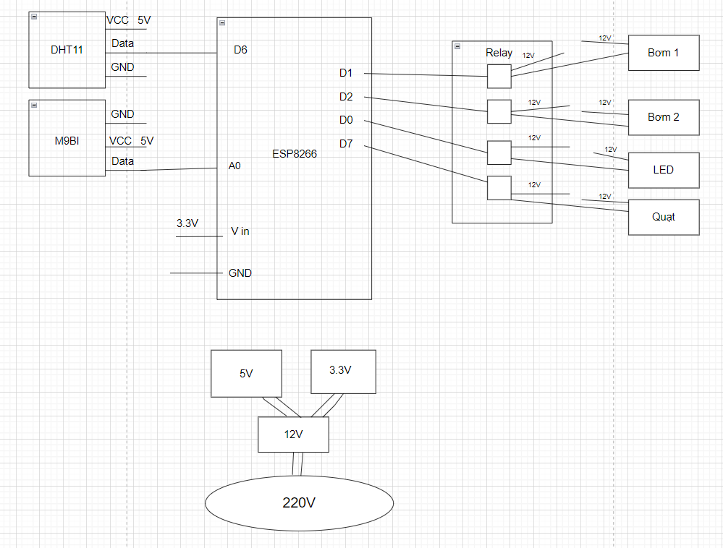

Figure 7 . Circuit of project

## 

## 

## 

## 

## 

## 5.2 Algorithm flowchart

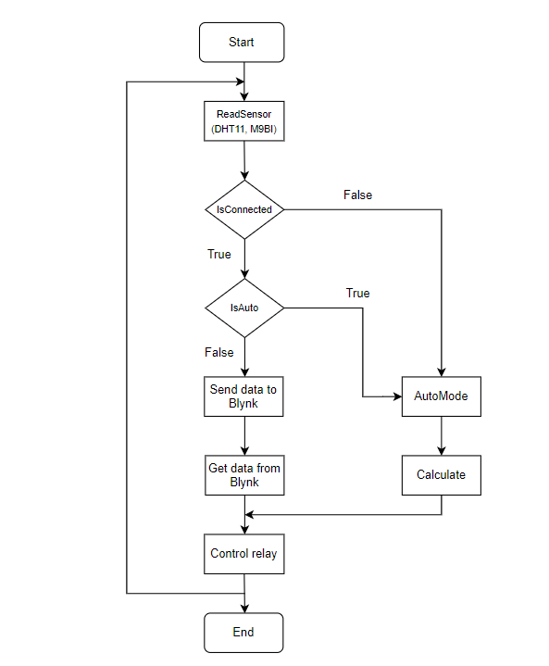

Figure 8 . Algorithm flowchart of project

* Firstly, the device reads data and parameters from sensors (DHT11, M9BI).

Next, the system checks if it is connected to the internet. If not, it automatically switches to the Auto state. If it is connected to the internet, the system further checks if the Auto mode is enabled.

* Next, the system checks if Auto mode is enabled. When the Auto mode is enabled, the system transitions to the Auto state. If it is not enabled, the system operates in Manual mode.
* In Manual mode, the system is controlled through the App/Web. Data read from the sensors is sent to the Cloud and displayed on the App/Web interface. The system receives control data from the App/Web and then controls the relays to turn on/off the output devices such as LED lights, fans, irrigation pumps, and misting pumps.
* In Auto mode, data from the sensors is used to calculate and control the output devices based on predefined values.
* This process is repeated until the system stops operating (End).

# **6. Results and Discussion**

## 6.1 Blynk web interface

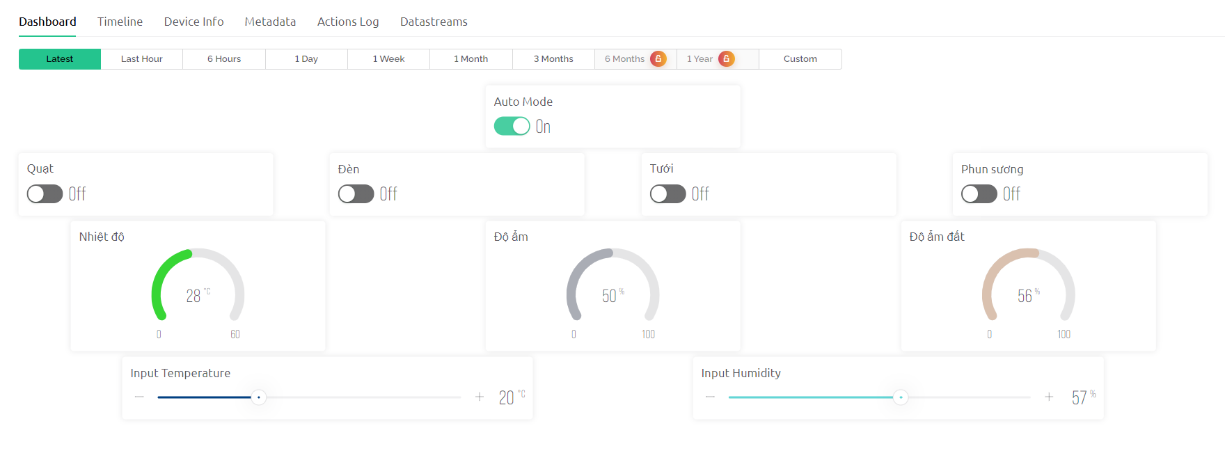

Figure 9. Web control screen

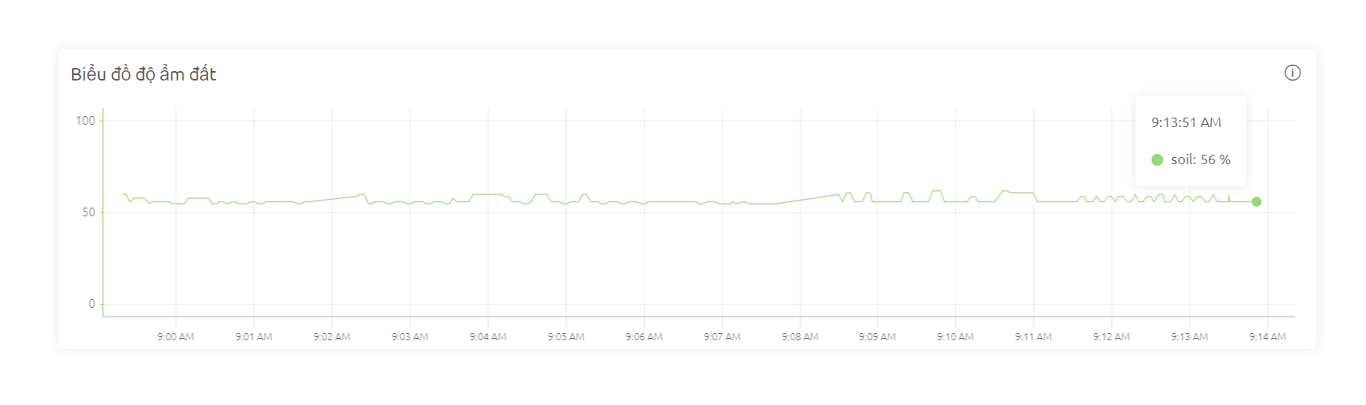

Figure 10. Soil moisture chart

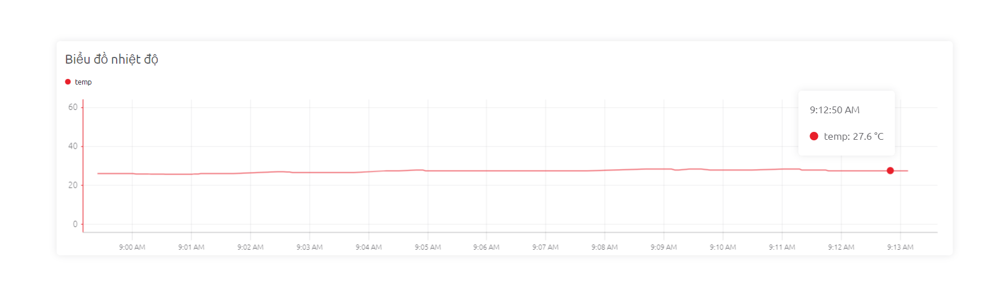Figure 11. Air temperature chart

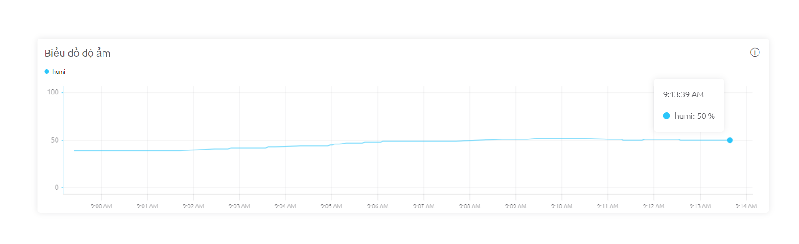

Figure 12. Air humidity chart

The user interface allows the user to select the Auto mode on or off. If the user chooses to enable the Auto mode, the system allows the user to input the standard temperature and soil moisture. In case the temperature exceeds the set temperature, the system automatically turns on the fan and misting system. If the soil moisture is lower than the set moisture level, the irrigation pump is automatically turned on.In that case, the control buttons for the irrigation pump, misting system, lights, and fan will be locked. If the user chooses to turn off the Auto mode, these control buttons will be unlocked, allowing the user to remotely control them based on the measured environmental parameters and receive back.

Additionally, there are charts displaying the temperature, air humidity, and soil moisture for the user to easily monitor.

## 6.2 Blynk app interface

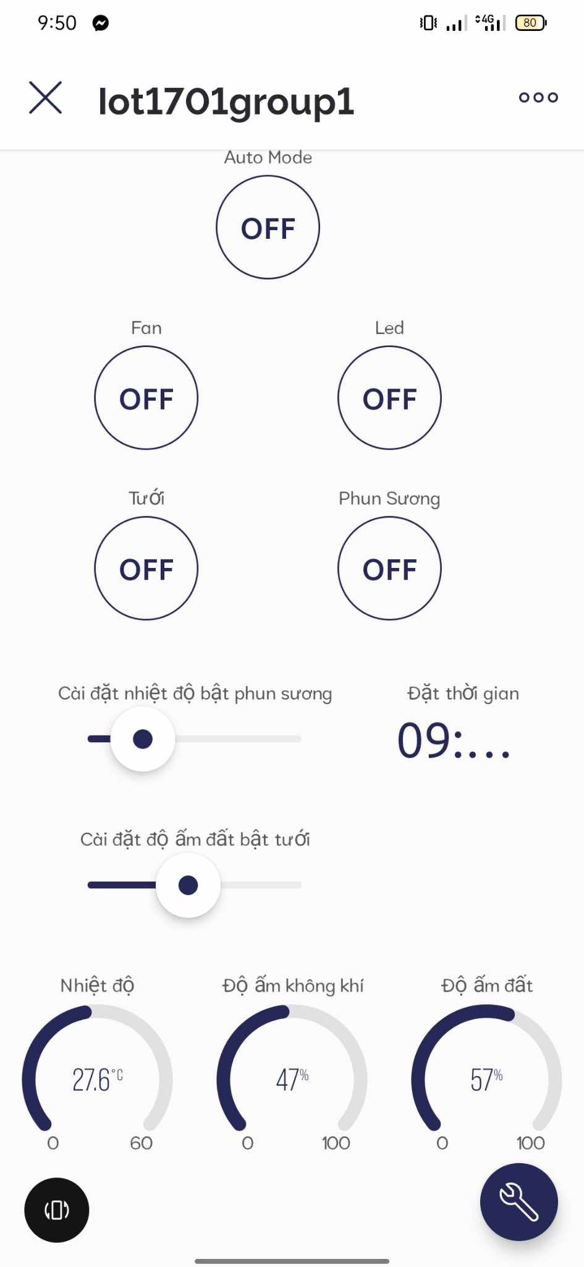

Figure 13. Mobile control screen

Basically the same as the Blynk app, additionally, there is an item for users to set the time to turn on the LED lights automatically.

# **7. Conclusion and development direction**

Applying IoT technology in the greenhouse allows us to control the environmental factors that directly affect lettuce plants, helping users save time and effort while still achieving similar or even better results compared to traditional methods. The user-friendly software interface facilitates easy monitoring of environmental parameters and convenient remote or automated control of devices without the need for human presence. The research findings are highly suitable for demanding horticultural needs and can minimize the reliance on manual labor.

The future development direction of the project is to integrate more sensors and solutions to achieve complete control over temperature and absolute humidity, allowing greenhouse owners to cultivate not only lettuce but also other types of plants.

# **8. References**

[1] Shirsath, D. S., Kamble, P., Mane, R., Kolap, A. D., & Dr, M. (2017). IOT based smart Greenhouse Automation using Arduino. International Journal of Innovative Research in Computer Science & Technology, 5(2), 234–238. https://doi.org/10.21276/ijircst.2017.5.2.4

[2]“Ăn rau xà lách có tốt không?,” Vinmec. https://www.vinmec.com/vi/tin-tuc/thong-tin-suc-khoe/dinh-duong/rau-xa-lach-co-tot-khong/

[3]Đ. T. Khuê and Đ. T. Khuê, “Xà lách và 16 lợi ích sức khỏe tuyệt vời đã được khoa học chứng minh,” Leep.app, Jul. 2022, [Online]. Available: https://leep.app/blog/dinh-duong/xa-lach.html

[4] Yablonski, B. (2023). 7 Lettuce Growing Stages with Pictures. *Backyard Gardeners Network*. https://backyardgardenersnetwork.org/lettuce-growing-stages/?fbclid=IwAR03fAuqY-xuo5sI93H06Ib1eEAlUvqt7cu5xGSm8zBJxezeIzMFoacVu1A#Germination_Emergence_of_Cotyledons

[5] Thạch H., “Thách thức, khó khăn trong hệ sinh thái nông nghiệp Việt Nam,” Tạp Chí Điện Tử Bảo Vệ Rừng Và Môi Trường, Apr. 2021, [Online]. Available: https://baovemoitruong.org.vn/thach-thuc-kho-khan-trong-he%CC%A3-sinh-thai-nong-nghie%CC%A3p-vie%CC%A3t-nam/

[6] R. K. Kodali, V. Jain, and S. Karagwal, IoT based smart greenhouse. 2016. doi: 10.1109/r10-htc.2016.7906846.

[7] M. S. Ullah et al., “Internet of Things based smart Greenhouse: remote monitoring and automatic control,” DEStech Transactions on Environment, Energy and Earth Science, no. iceee, Feb. 2019, doi: 10.12783/dteees/iceee2018/27803.